Homework

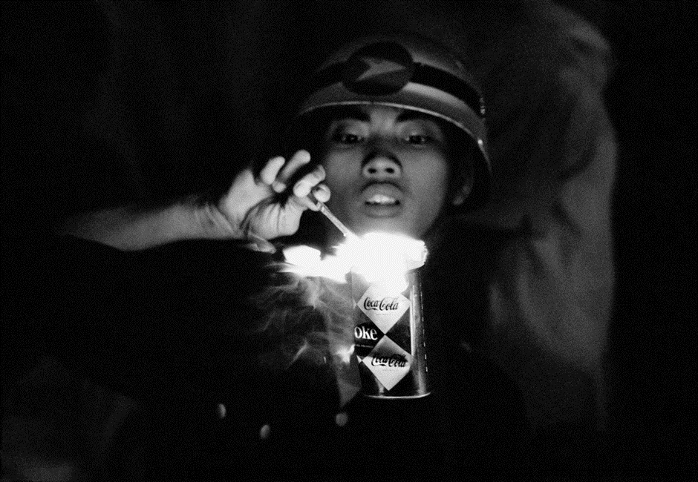

In the photo I can see that a girl that is holding a match and setting a can of coco cola on fire. My first impression was that there I anger because she is setting the can on fire and I ask myself why I she is doing that. I think the story behind the image I that there is conflict. There could be a war going on and the girl is taken part with what is going on.

The Photo was taken by Philip Jones Griffiths. The image was from the Vietnam War. The photographer wanted to change the publics attitude to the conflict. The actual story behind the image is that the Photographer was reporting this for three years. They wanted to show the conflict of the Vietnam war and the horror of it. Looking at the image again it makes me stop and think about the image more. It also makes me feel sorry for the girl.