
Location Sheet

Production Name: | When love takes over.
Group Members: | Esther Stephenson, Shamiam Arif, Callum Bates, Jubiar Ahmed
Date of Recce: | 25/09/19
Date of Production: | 30/09/19

Location Name: | Skills for life room | Name of Contact: | Maria Sexton or Sandra Stack
Location Address: | New Bedford Rd,  Luton  LU2 7BF
 |  | Contact Telephone:
 |  | Contact Email: | Natalie.Sexton@barnfield.ac.uk

Areas Required: |  |  | Scenes/Shots being captured at this location:
The kitchen table |  |  | The beginning
The bed |  |  | The beginning
The sofa |  |  | At the beginning
Nearest Medical Support: |  | Lewsey Rd,  Luton  LU4 0DZ
Safety Concerns: |  | N/A
Police Requirement: |  | No, we need any because we have nothing that requires the police
Security Issues: |  | We don’t need to have any security as we are using a room in college
Private/Public Use: |  | It is public use
Staging Area: |  | While we are filming we hope to use the room next door to keep everyone and the equipment bags
Power Supply: |  | We need extra batteries for the camera
Parking Access: |  | The car park is in front of the college and behind it.
Noise Concerns: |  | We will have some noise concerns but what we will do is make sure the area is quite will we shoot. If there is a class we will make sure the door is closed.
Location Notes:

There is a fire exit down the corridor it is easy to get to. We need to make sure that we have enough space to film in the bedroom as it is quite small.
Please attach a picture of the location:
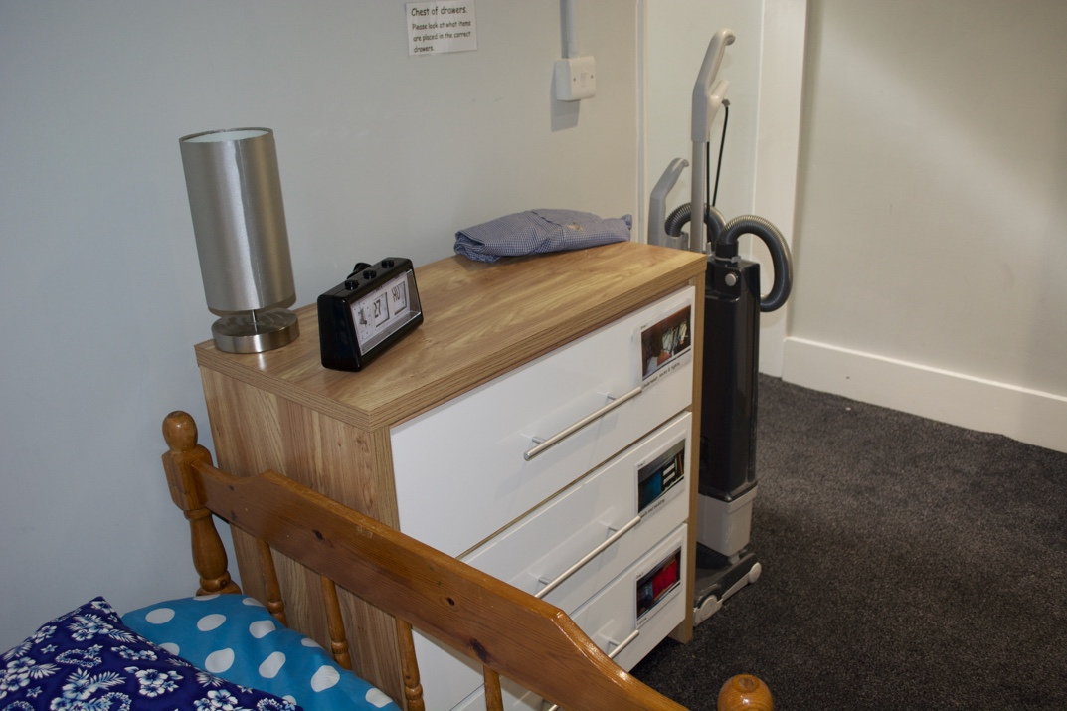

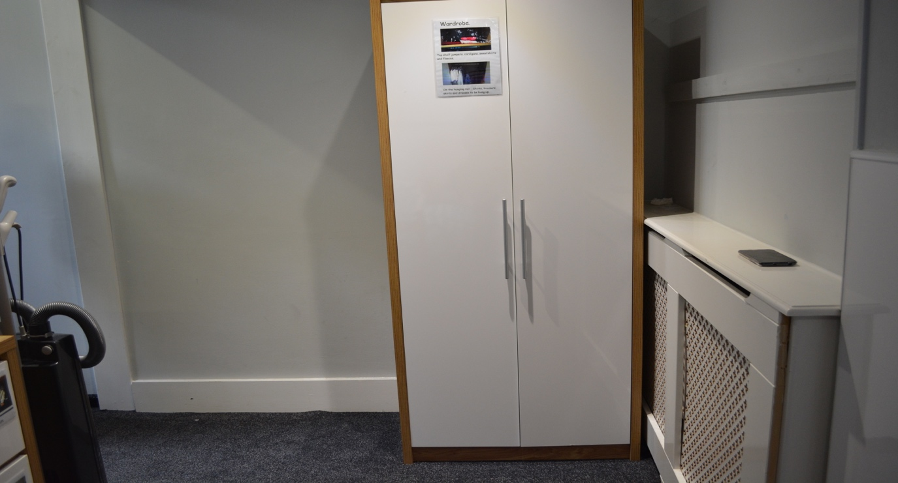

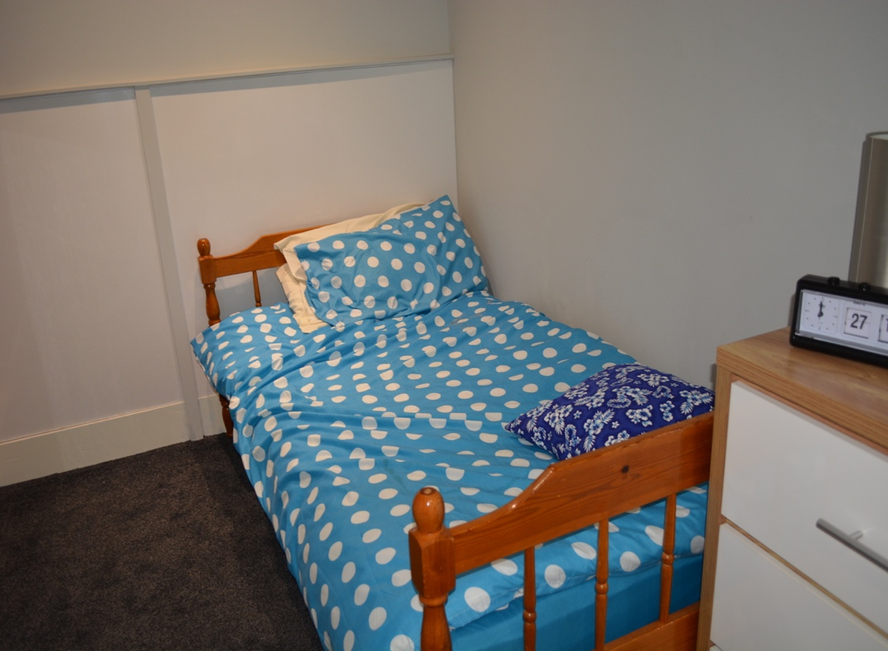

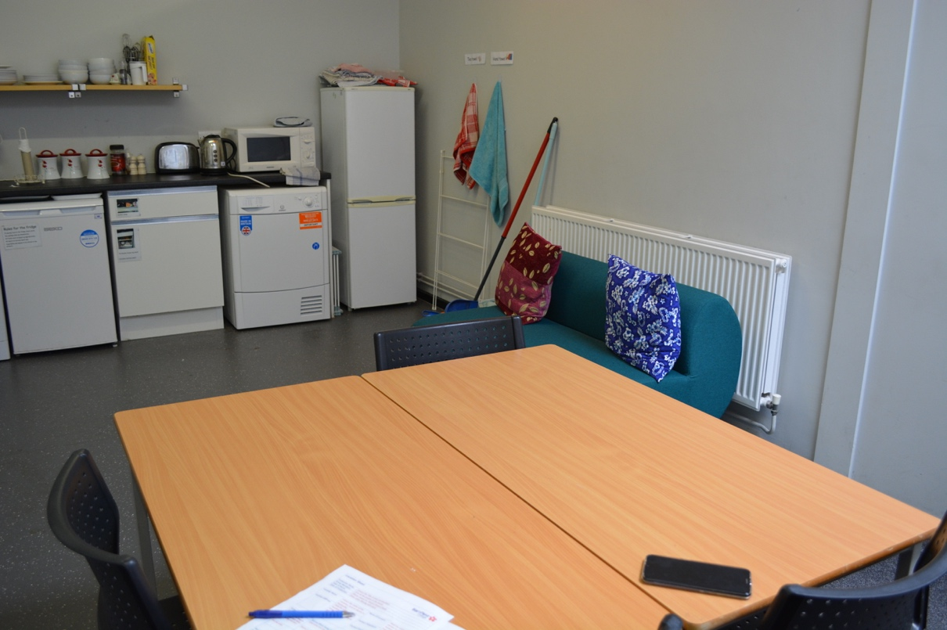

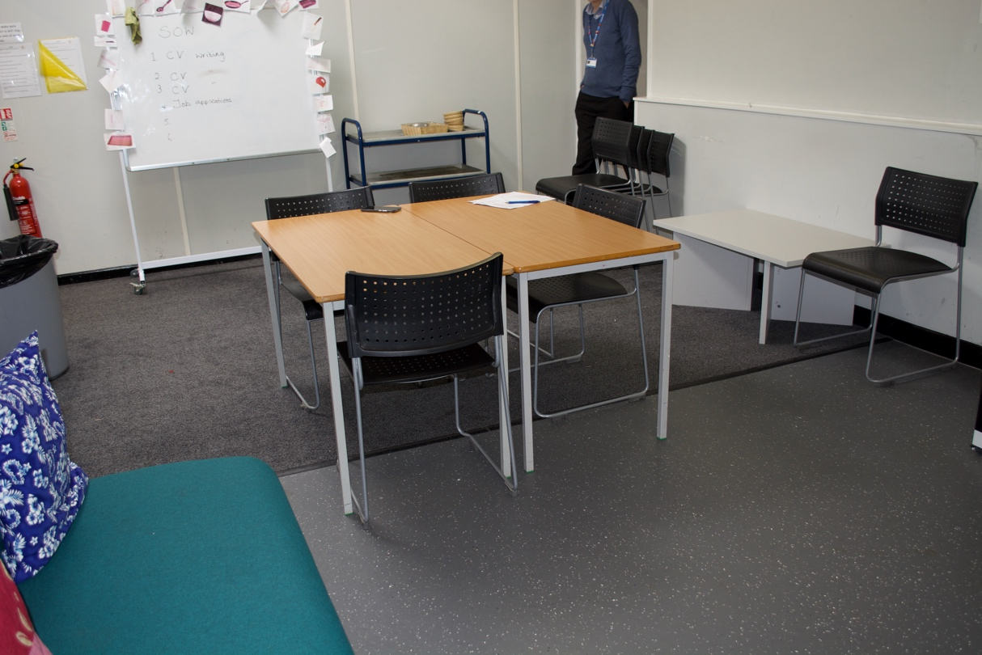

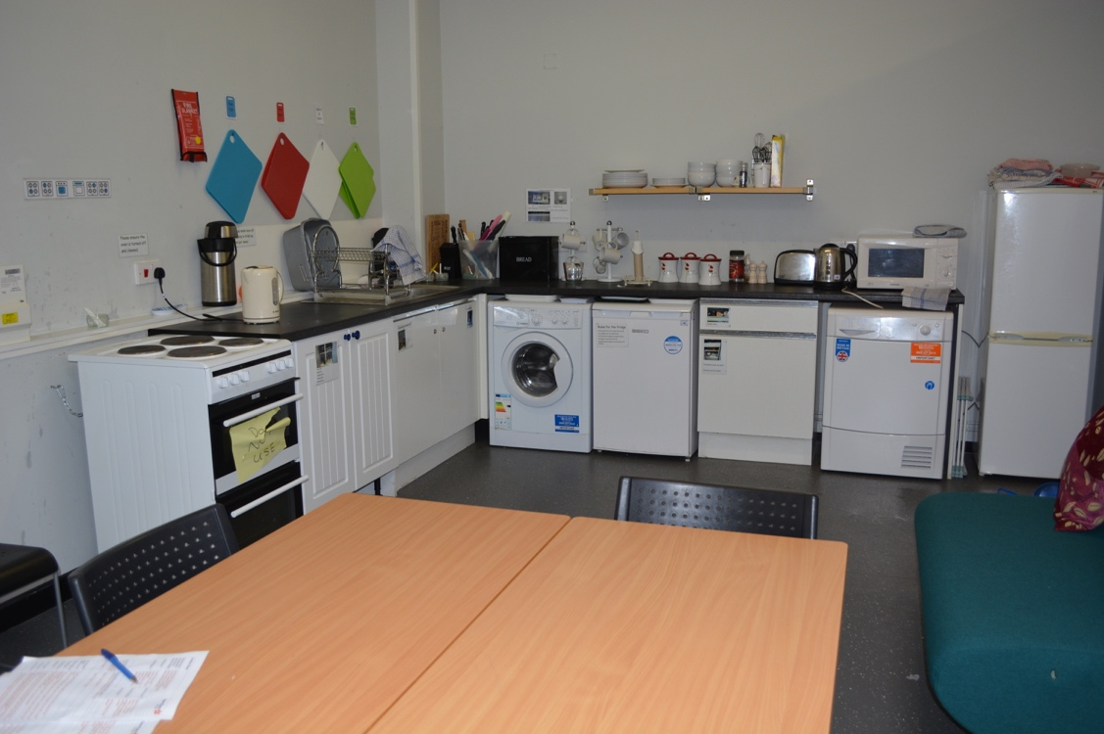

Please attach directions to get to your location:

