Storyboard

Production title:

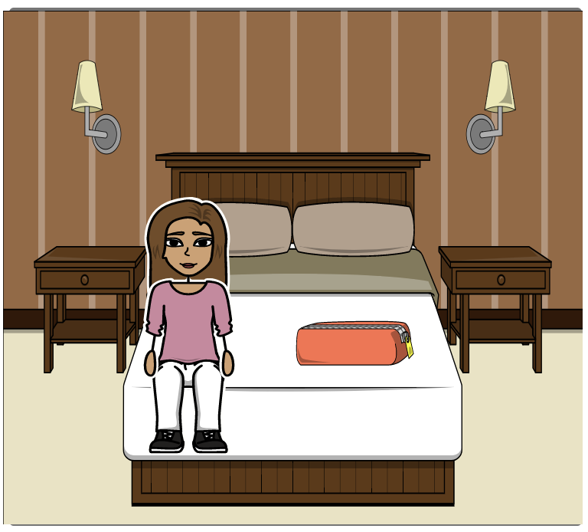 | Scene number: 1
 | Shot number:1
 | Shot type:
 | XCU |  | CU |  |  | MS |  |  | LS |  | XLS
 | Other: wide shot
 | Scene description: I am going to introduce the video.
 | Audio description:
 | Interior |  |  |  | X |  |  | Day |  |  |  | X
 | Exterior |  |  |  |  |  |  | Night

 | Scene number: 1
 | Shot number:2
 | Shot type:
 | XCU |  | CU | X |  | MS |  |  | LS |  | XLS
 | Other:
 | Scene description: I will do a close up of the products that I will be using.
 | Audio Description:
 | Interior |  |  |  | X |  |  | Day |  |  |  | X
 | Exterior |  |  |  |  |  |  | Night

 | Scene number: 1
 | Shot number:3
 | Shot type
 | XCU |  | CU |  |  | MS |  |  | LS |  | XLS
 | Other: Wide shot
 | Scene description: I will Start to apply the base of my makeup and explain why I use it
 | Audio Description:
 | Interior |  |  |  | X |  |  | Day |  |  |  | X
 | Exterior |  |  |  |  |  |  | Night

 | Scene number: 1
 | Shot number: 4
 | Shot type
 | XCU |  | CU |  |  | MS |  |  | LS |  | XLS
 | Other: Wide shot
 | Scene description: I will use the wide shot because I will start to apply my foundation and explain the technique I am using.
 | Audio Description:
 | Interior |  |  |  | X |  |  | Day |  |  |  | X
 | Exterior |  |  |  |  |  |  | Night
 | Scene number: 1
 | Shot number:5
 | Shot type
 | XCU |  | CU | X |  | MS |  |  | LS |  | XLS
 | Other:
 | Scene description: I will use the close up to show what color eyeshadow.
 | Audio Description:
 | Interior |  |  |  | X |  |  | Day |  |  |  | X
 | Exterior |  |  |  |  |  |  | Night
 | Scene number: 1
 | Shot number:6
 | Shot type
 | XCU |  | CU |  |  | MS |  |  | LS |  | XLS
 | Other: Wide shot
 | Scene description: I will wide shot to show me how I am applying the eye shadow
 | Audio Description:
 | Interior |  |  |  | X |  |  | Day |  |  |  | X
 | Exterior |  |  |  |  |  |  | Night

 | Scene number: 1
 | Shot number:7
 | Shot type
 | XCU |  | CU | X |  | MS |  |  | LS |  | XLS
 | Other:
 | Scene description: In this scene I will use close up of the next product.
 | Audio Description:
 | Interior |  |  |  | X |  |  | Day |  |  |  | X
 | Exterior |  |  |  |  |  |  | Night
 | Scene number: 1
 | Shot number:8
 | Shot type
 | XCU |  | CU |  |  | MS |  |  | LS |  | XLS
 | Other: Wide shot
 | Scene description: I will use for a wide shot to show the technique of how I am applying the product
 | Audio Description:
 | Interior |  |  |  | X |  |  | Day |  |  |  | X
 | Exterior |  |  |  |  |  |  | Night
 | Scene number: 1
 | Shot number:9
 | Shot type
 | XCU |  | CU | X |  | MS |  |  | LS |  | XLS
 | Other:
 | Scene description: I will use the close up to show the color of the product.
 | Audio Description:
 | Interior |  |  |  | X |  |  | Day |  |  |  | X
 | Exterior |  |  |  |  |  |  | Night

 | Scene number: 1
 | Shot number:10
 | Shot type
 | XCU |  | CU |  |  | MS |  |  | LS |  | XLS
 | Other: Wide shot
 | Scene description: I will use a wide shot to show the technique I am using.
 | Audio Description:
 | Interior |  |  |  | X |  |  | Day |  |  |  | X
 | Exterior |  |  |  |  |  |  | Night
 | Scene number: 1
 | Shot number:11
 | Shot type
 | XCU |  | CU | X |  | MS |  |  | LS |  | XLS
 | Other:
 | Scene description: I will use close up of the next product I will be using
 | Audio Description:
 | Interior |  |  |  | X |  |  | Day |  |  |  | X
 | Exterior |  |  |  |  |  |  | Night
 | Scene number: 1
 | Shot number:12
 | Shot type
 | XCU |  | CU |  |  | MS |  |  | LS |  | XLS
 | Other: Wide shot
 | Scene description: I will use a wide shot to show the final look.
 | Audio Description:
 | Interior |  |  |  |  |  |  | Day
 | Exterior |  |  |  |  |  |  | Night
 | Scene number: 1
 | Shot number:13
 | Shot type
 | XCU |  | CU |  |  | MS |  |  | LS |  | XLS
 | Other: Wide shot
 | Scene description: I will use wide shot to do the outro of the show.
 | Audio Description:
 | Interior |  |  |  | X |  |  | Day |  |  |  | X
 | Exterior |  |  |  |  |  |  | Night

