
Location Sheet

Production Name: | CJES Production
Group Members: | Shamiam, Esther, Callum, Jubiair
Date of Recce: | 25/09/19
Date of Production: | 30/09/19

Location Name: | Music Booth | Name of Contact: | Michael
Location Address: | Barnfield College  New Bedford Road  LU2 7BF
 |  | Contact Telephone:
 |  | Contact Email:

Areas Required: |  |  | Scenes/Shots being captured at this location:
The Music Booth |  |  | This scene the girl will be singing to the camera. She will be singing the chores all the time. She will walking to the college and then going into the music room and too the music booth and putting her headphones on and singing into the mic.
Nearest Medical Support: |  | L & D Hospital or the First aid Kit
Safety Concerns: |  | The safety concerns is that when the girl will b singing she has to make sure she doesn’t bump into things because what she singing an accident falls and breaks the music students drums then we will have to pay. If she spills something when then the computers will get broken and we will have to buy.
Police Requirement: |  | There won’t be any Police requirement as we are in a private area however, there will be college security all around the college so they will help and stop people.
Security Issues: |  | The security is that the college gives out pass to the students that go to the college and there is no other way of getting in so that means that the college is a safe places. They will security in the front of the college before you walk in and in the reception and than area the back and in the hallways. So you are always protect.
Private/Public Use: |  | This is Private location so that means no one in the public will come a n interfere with what you are doing. Th college is a private area for students to have fun and do their courser.
Staging Area: |  | The area that we will be shoot is going to in the music booth in front of the mic and we will be putting equipment bags outside the booth because we don’t want that in he shot and if we did then we have to start the whole scene again.
Power Supply: |  | We will being needed an extra battery and an extra SD card because we will be film the whole day and then our battery and SD card will ruin out and we won’t be allowed to go back and forth all the time.
Parking Access: |  | They will be allowed car park access to people who have a car. The college will let you go in without paying but there will be security guards out to see what is happening. You can park in the front of the college or be hind the college but mostly the visitors park in front of the college.
Noise Concerns: |  | They will be noise concerns because they will be music students still in class so that means they will talking and playing instruments. I think that the music booth is sound proof so we will hear it outside the booth but inside we won’t be able to hear.
Location Notes:

When getting out from the music room we take a left and go through the doors. Between the hall there is a fire exit for when there is a fire.

Please attach a picture of the location:

(Take a selection of pictures of your location and add them in here)

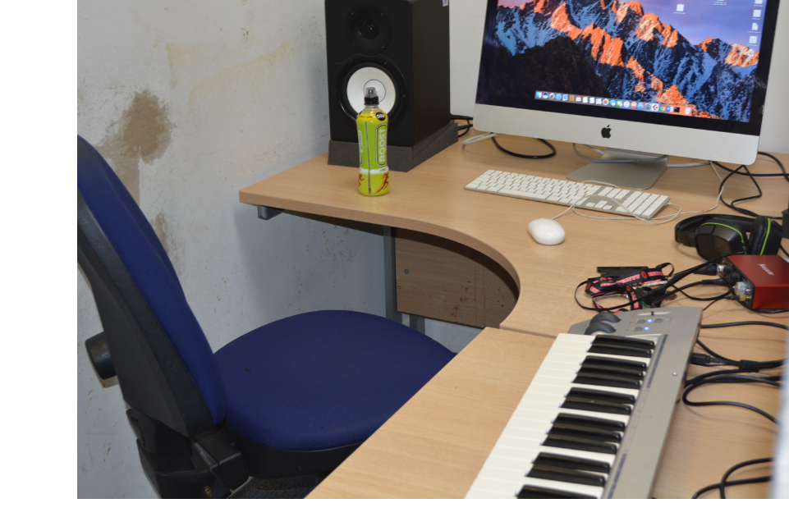

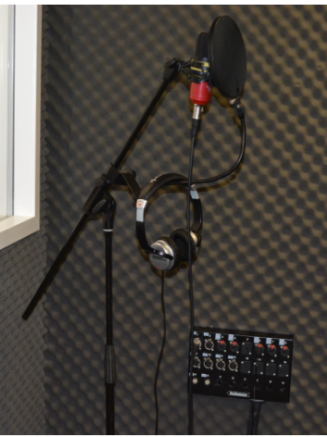
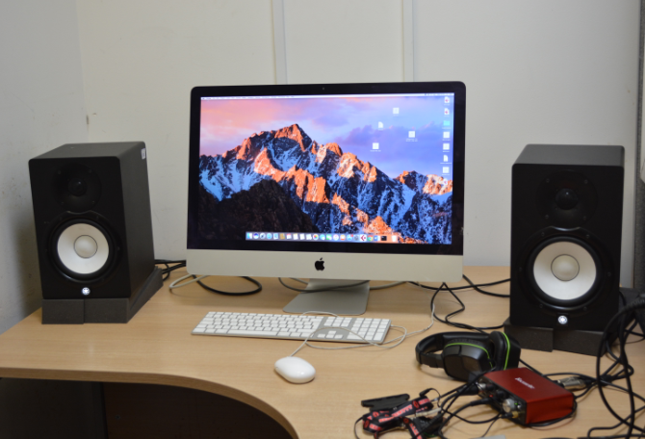
Please attach directions to get to your location:

(Use google maps to get a map and directions to your location, attach it here)
