Brunel university London
Media and communications
Entry requirement:
- Tariff not accepted
- A level
- Pearson BTEC level 3 extended diploma
- Access HE diploma
- Obtain a minimum of 112 UCAS tariff points in the Access to HE Diploma with 45 credits at Level 3.
Coventry University
Media and communications
Entry requirements
- A level
- Pearson BTEC Level 3 Extended Diploma
- Access to HE Diploma
- GCSE English at grade 4 or above.

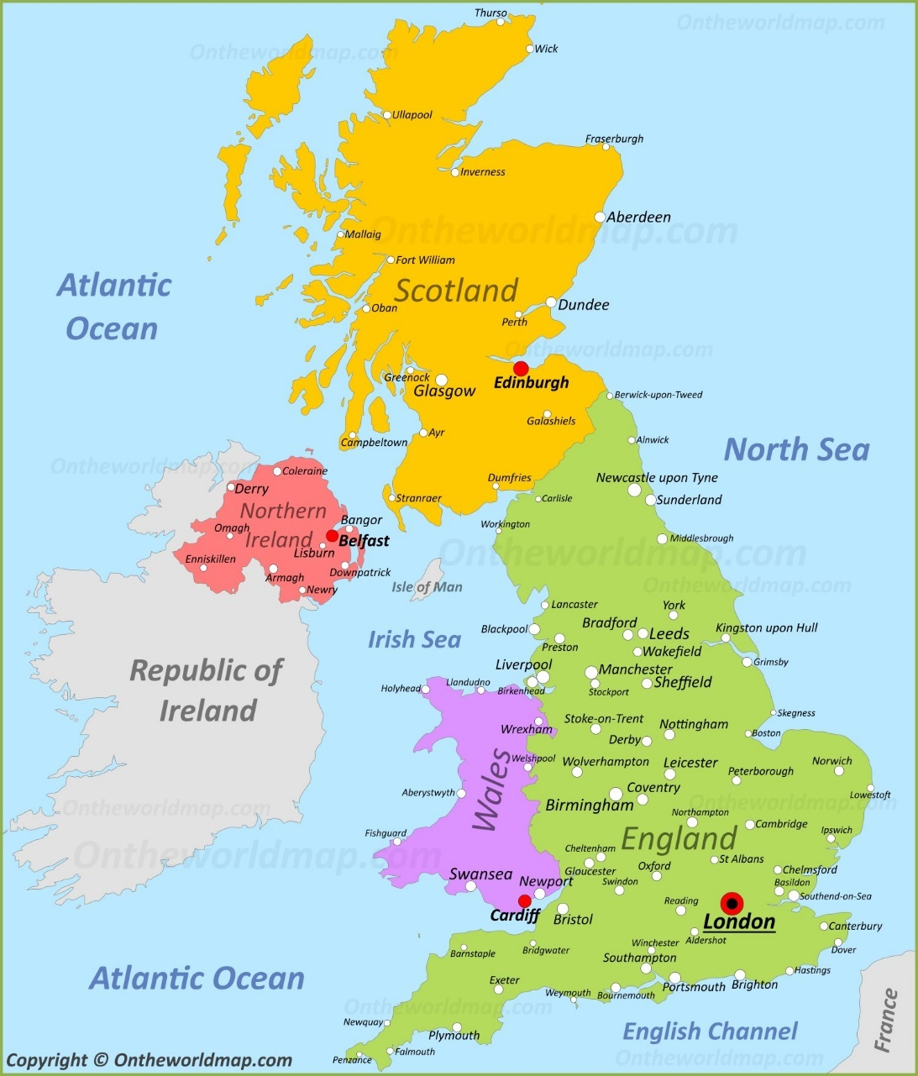
production
UAL
Magazine journal and publishing
Entry requirements:
- Points to be confirmed
Bournemouth university
Media production
Entry requirements:
- 104 - 120 points
- 104 - 120 tariff points including a minimum of 2 A-levels or equivalent
- Pearson BTEC Level 3 Extended Diploma
- DMM 112 tariff points
- Access to HE Diploma
- 102 - 118 tariff points any combination of Distinction, Merit, Pass grades
Bournemouth University
Communications and media
Entry requirement:
- 104-120 points including a minimum of 2 A- levels or equivalent
- Pearson’s btec Level 3 extended diploma
- DMM 112 tariff points
- Access to HE diploma
- 102-118 tariff points with any combination of Distinction, merit, pass grades
UWE
Media communications with foundation year
Entry requirements:
- 64 points
- A level
- Pearson Btec level 3 extended diploma
- Access to HE diploma
- GCSE/National 4/ National 5
- Grade c/5 in English/literature/ language or equivalent
UWE
Media production
Entry requirement:
- 112 points
- A level
- Persons BTEC level 3 national extended diploma
- Access to HE Diploma
- GCSE/ National 4/ National 5
- Grade c/4 in English literature/ language or equivalent.

Buckinghamshire new university
Media production
Entry requirements:
- 80 Points
University of Hertfordshire
Media
Entry requirements
- 104 points
- A level
- Pearson BTEC level 3 extended diploma
- GCSE/ National 4/ National 5
- English 4/c Maths 4/d

Coventry university
Film
Entry requirement:
- 1 point
- A level
- To include one from Film Studies, Media or a related subject
- Pearson BTEC Level 3 Extended Diploma
- DDM in Media.

