
Location Sheet

Production Name: | Esther Eats
Group Members: | Esther Stephenson
Date of Recce: | 23/04/2021
Date of Production: | 26/04/2021

Location Name: | Home | Name of Contact: | Esther Stephenson
Location Address: | 23 Oakley Close  Lu4 9ql  Leagrave
 |  | Contact Telephone: | 07498569850
 |  | Contact Email: | estistephenson2002@gmail.com

Areas Required: |  |  | Scenes/Shots being captured at this location:
Kitchen |  |  | In the Kitchen I want to capture the food cooking and the plating of the food.
Living room |  |  | In the living room I will be capturing the final product.
Nearest Medical Support: |  | Lewsey Road, Luton, LU4 ODZ
Safety Concerns: |  | As I am using a kitchen there are many safety concerns for example the fire from the cooker and hot water could burn me. Another one is I am using a knife so I could cut my self.
Police Requirement: |  | I do not need to let the police know anything.
Security Issues: |  | I do have access to home as I have a key.
Private/Public Use: |  | The location is is private as it is my home
Staging Area: |  | I will put the equipment bag in the dining room so that they are out of the way
Power Supply: |  | I have enough power supply as there are plugs around the room.
Parking Access: |  | There is parking outside my house as I have a drive.
Noise Concerns: |  | As I am taking pictures so I don't need to worry noise concern.
Location Notes:
I need to make sure that I do not disturb my sister as she is still working from home.
Please attach a picture of the location:
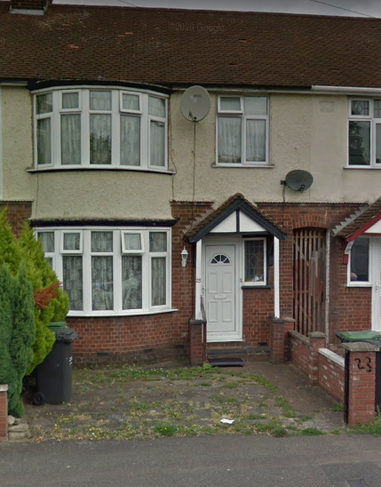

Please attach directions to get to your location:

