
Location Sheet (BATHROOM)

Production Name: | Hostile
Group Members: | Chloe, Kayley, Callum, Esther and Kacper
Date of Recce: | 14/10/20 + 15/09/20
Date of Production: | 14/10/20 + 15/09/20

Location Name: | College TV studio | Name of Contact: | Kacper Zuber
Location Address: | New Bedford Road, Luton LU2 7BF
 |  | Contact Telephone: | 07512329453
 |  | Contact Email: | ZUB19006010@barnfield.ac.uk

Areas Required: |  | Scenes/Shots being captured at this location:
Bathroom |  | Scene 2 (mirror scene)
Nearest Medical Support: |  | Medical room on campus or L&D hospital.
Safety Concerns: |  | Bathrooms recordings are not permitted in most cases due to hygiene concerns  The floors may be wet aswell and as such we would have to watch ourselves and the equipment.
Police Requirement: |  | No police requirements are needed
Security Issues: |  | Swipe badge to get onto the campus to then go into the TV studio
Private/Public Use: |  | Private location
Staging Area: |  | In the Bathroom we will NOT be able to place the bags and tripods in and around the area we are using to film as the floors may be wet and it is unhygienic to do so. Everything will be able to be placed outside under supervision while we use a hand hand held shot avoiding any contacts with the bathroom objects.
Power Supply: |  | main power supply will be the individual cameras battery so we must ensure it’s charging is adequate for the filming period.
Parking Access: |  | Free parking or a bus stop right outside  Will have to use a badge to get in but only a certain amount of people because of Covid-19 concerns
Noise Concerns: |  | We might be able to hear people walking past the as well as the neighbouring corridor across the Bathroom TV studio as it is next to the main corridor. We might also hear things being moved around from the department upstairs.
Location Notes:
We are recording on the days that we are in college but we need to wait to see if one of our actors will be allowed inside of the building because of covid-19.

There are plenty of fire exists near the room we are using and loads of ways to access the different rooms and things we need.
Please attach a picture of the location:

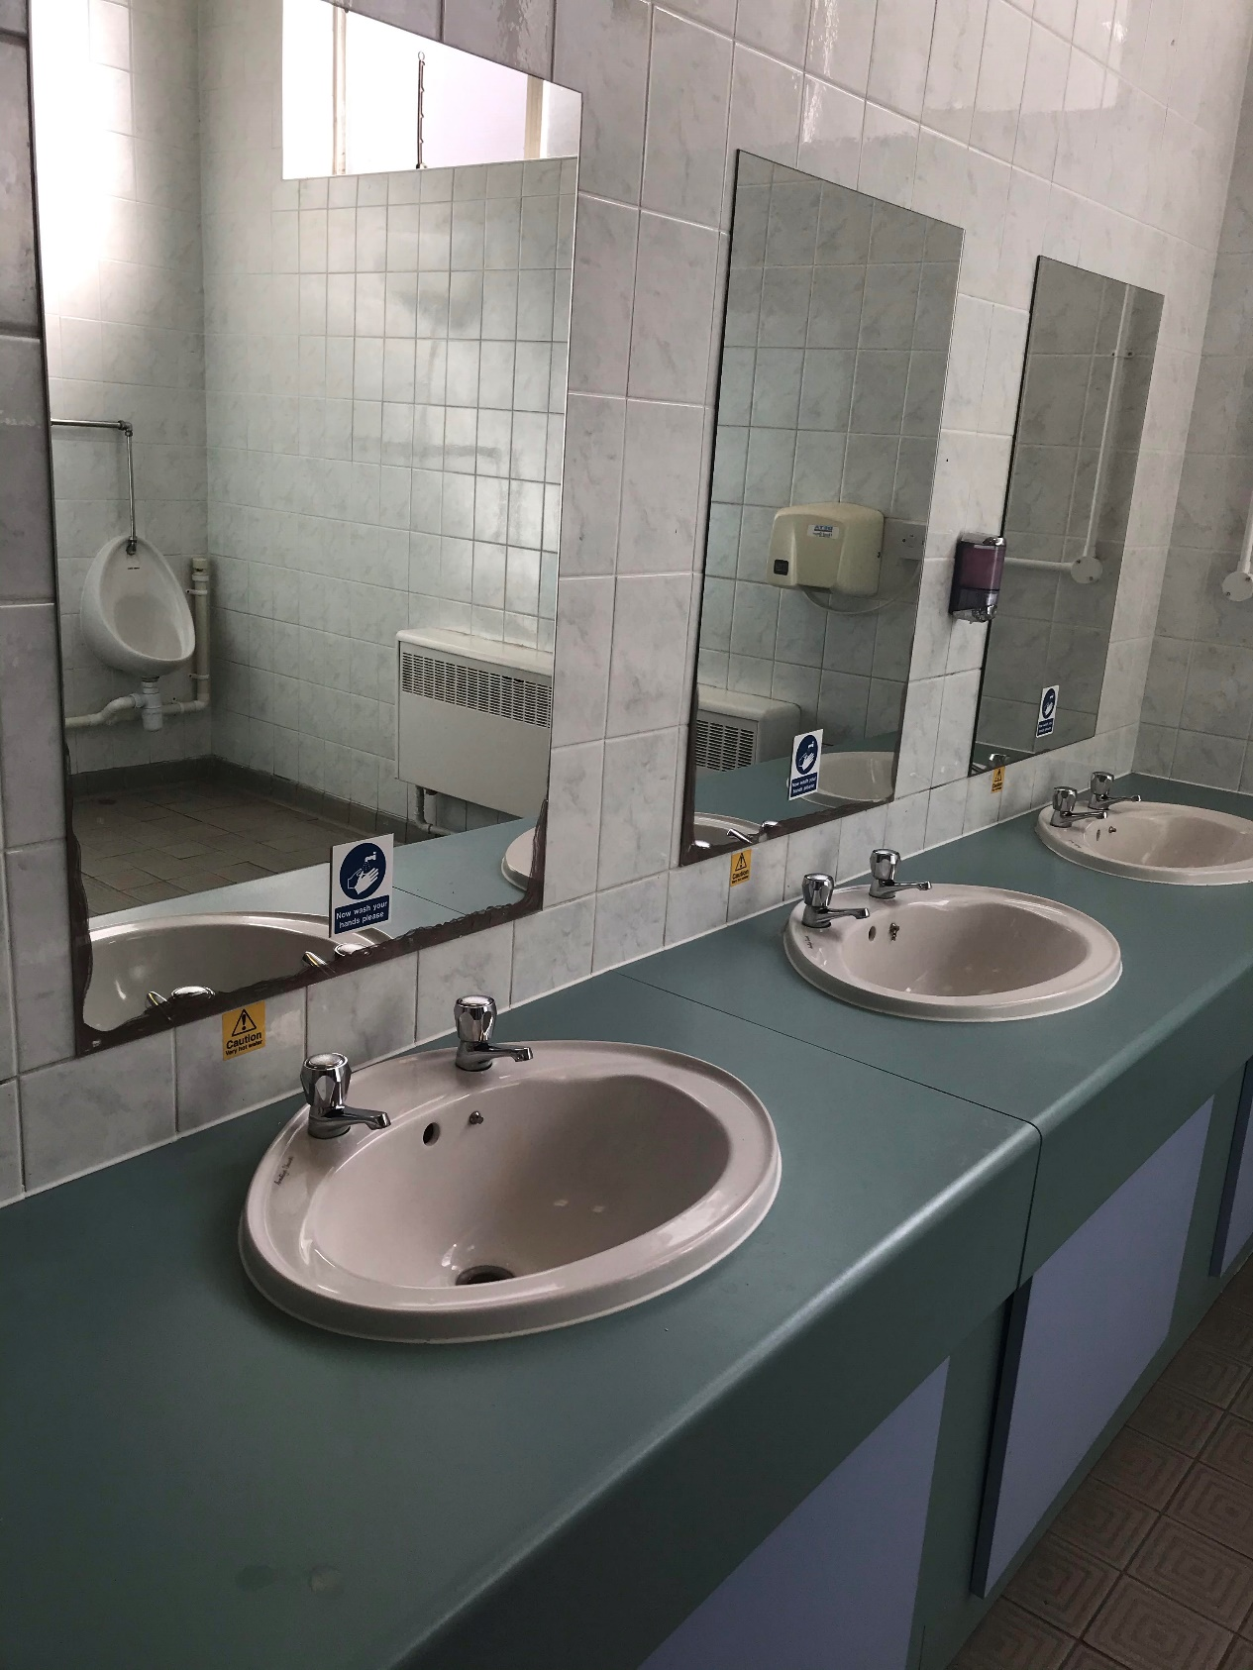

Please attach directions to get to your location:

