Storyboard

Production title:

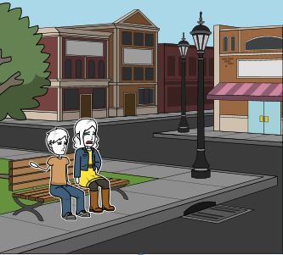 | Scene number:
 | Shot number:
 | Shot type
 | XCU |  | CU |  |  | MS | X |  | LS |  | XLS
 | Other:
 | Scene description: The girl is crying to her boyfriend and he comforts her.
 | Audio description:
 | Interior |  |  |  |  |  |  | Day |  |  |  | X
 | Exterior |  |  |  | X |  |  | Night

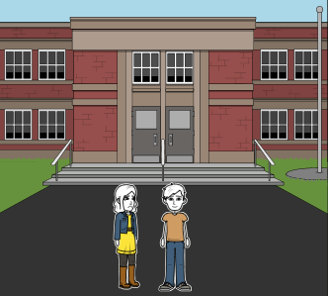 | Scene number:
 | Shot number:
 | Shot type
 | XCU |  | CU |  |  | MS |  |  | LS | X | XLS
 | Other:
 | Scene description: They are walking into the college to go to Starbucks
 | Audio Description:
 | Interior |  |  |  |  |  |  | Day |  |  |  | X
 | Exterior |  |  |  | X |  |  | Night

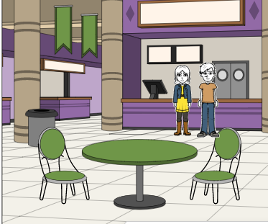 | Scene number:
 | Shot number:
 | Shot type
 | XCU |  | CU |  |  | MS |  |  | LS | X | XLS
 | Other:
 | Scene description: They are in Starbucks getting a coffee and going to lesson
 | Audio Description:
 | Interior |  |  |  | X |  |  | Day |  |  |  | X
 | Exterior |  |  |  |  |  |  | Night

