Font justification
There are a lot of fonts that I can choose from for this unit. I will create a selection of different fonts for my headlines and the body of my fonts so that I can choose fonts for my project. I will decide why I like or dislike the font and why.
Headlines | Likes, dislikes and why
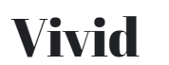 | I like this font because it is bold, and it catches my eye. This font shows me that it is classical. This font gives the people the idea that the font is for a magazine like vogue. I would not use this font for my double page spreads.
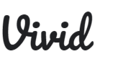 | I like this font because it stands out and it catches my eye. I also dislike that it can be hard to read for some people. The font also gives people the idea that the project is mainly for females. I would not use this font as my project is for both males and females.
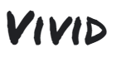 | I like this font because it is easy to read, it is bold, and everyone will enjoy the font as it does not seem girly at all. This font gives the idea that it was handwritten with a permanent marker. I am thinking about using this font.
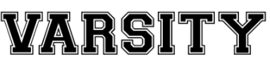 | I like this font because it is bold, it stands out to people and catches people’s attention. I like that it gives people the idea that it is old school. I would like to choose this font for my units.
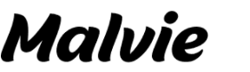 | I like this font because it tilts to the side slightly and that it has a bit of movement in the lists. Many people would like this font because it is easy to read and that it is bold and eye catching. I would consider this font for my project
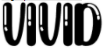 | I like this font because it is bold and bubbly. I also dislike the font because this doesn’t go with what I was looking for my project. This font is more for children as it is bubbly. I would not consider using this font.

Body | Likes, dislikes and why
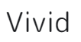 | I like this font because it is easy to read and it appeals to both genders. I do not like the spacing between the letters. For my project I would consider using this font.
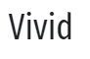 | I like how this font is bold but stands out. It is not complicated to read. This font gives me an idea that it is simple to use. I would consider using this font for my project.
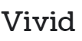 | I like that this font is bold, and it stands out to people. This text gives the idea of mystery but simple. I like this font for my project
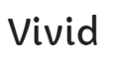 | I like that this font is easy to read and that it is bold. I do not like the spacing because it can take a lot more space on the page. This font gives me the idea that it is simple, but it is also bubbly. I would consider this font for my project.
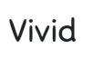 | I do not like this font for my project because it is a font that would be used for something that is childish. I would not use this font for my project.
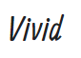 | I like that this font is simple. I also like that is in italics. I like that this fonts gives the idea of simple but bubbly at the same time. I would consider the font for my project.
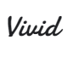 | I like that this font is cursive, bold and that it stands out. I dislike that it this font is not as easy to read. I would not use this for my project.

