Font Justification
For my magazine I will be choosing fonts. I am going to create a range of different fonts for my magazine so that I can choose the fonts I want to use in my magazine. I created a table on what fonts I like, dislike and why.
Headlines | Dislike, Likes and Why?
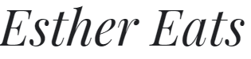 | I like this font because it catches my eye. The font is classy, simple and that it is clear and easy to read. The font does not seem girl so I think the font is gender neutral. I am thinking of using this font for the headline of my magazine.
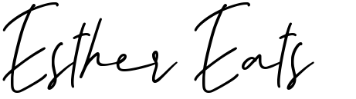 | I like this font because it is simple. The font makes me think of an Italian ready-made meal. So, it instantly made me think of food. As I previously said, it makes me think of Italian ready-made meals. It might not be as easy to read the font as it is cursive. I would like to use this font in my magazine as it would catch the audience's attention but I am not going to use this font because it is not easy to read.
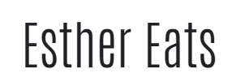 | I like how the font catches my eye, simple and bold. I like that it stands out to you. It is not complex. It is easy to read so people won’t find it hard to read. I am thinking about using this in my magazine as it is simple and clear.
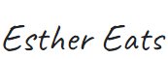 | The font is simple, not complex. I like that it looks like it is written freehand and that it was written quickly. It has that sketchy kind of look to it. I dislike this font because it makes me feel like the font is for a children's magazine rather than a cooking magazine.
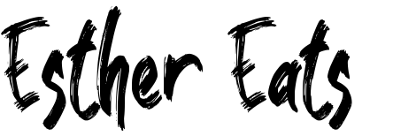 | The font is bold. It is easy to read. It looks like it was written by a paint brush as it has that feel to the font. I feel like it is for a children's magazine as it looks more childish as it looks like it has been painted. It does catch your attention but I don't think it is the right font for my magazine.
 | It is bold, simple and stands out. It is different from all the other fonts I chose. I like how it has theos lines running through the font as it looks like the font is breaking but on the other hand it reminds me of cooking and the mess of it. I think this font would be a good one to include in my magazine because it is different and it stands out to people.
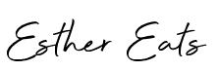 | This font has a sleek finish to it. I like it because it has a classy but simple look to the font. The font stands out and definitely catches the eye and people's attention. I think that out of the different fonts this is the best font. I like this font very much so I think that this font is one that I will choose for my magazine as it is something that would definitely catch my target audience's eyes.

Body

Font | Likes, dislikes and why
 | I like that the font is simple but it catches people's eye. I also like that it is easy to read and that it is clear. The font is gender neutral. I would consider using this font for my magazine because it is simple and clear for people to read.
 | The font is simple but easy to read. The font is not complex. It stands out because the font is not in bold it is thin so I will be able to fit more information. I am thinking of using this font for my magazine. I don't like the spacing between the letters. I am thinking of looking for something similar to this but one that has less spacing between the letters.
 | I like that this font is simple. Easy to read and clear but I do not like that it looks like it is for a children's magazine. I say that because it has a childs feel to it. I would not use this font for my magazine because I feel like that the font is for children so I don't want to use the font in my magazine.
 | The font is clear and easy to read. It is not complex at all. I Feel like the font reminds of disney as it has that type of style to it so i think that this font is not for my magazine because I am creating a cooking magazine
 | I like that the font is different to the previous fonts I have chosen. I like that the font is cursive but it is not clear or easy to read so it would not make a good font for my magazine. I don't like that the font is complex so certain people would not be able to read the information. Ther font is not gender neutral as it seems really girly.
 | I like that it is similar to the previous fonts that I chose. It is simple but it catches the eye. It has less spacing between the letters. Easy to read and clear to read so it is not complex. The font is gender neutral as it is simple. I am considering this font in my magazine because it is simple.

