Sound mixer analysis

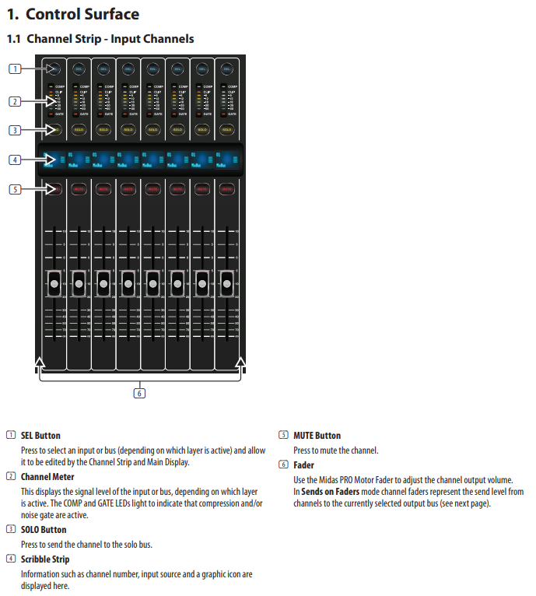

There are more pages that are important. These tells me what each button does on the audio mixer I have learnt what each button does on the mixer as this will help know what to when it comes to the rehearsals and recording live. There are 3 to 4 pages that summarises the whole section so if I need to find how to do something or what it does I can go back to those pages.

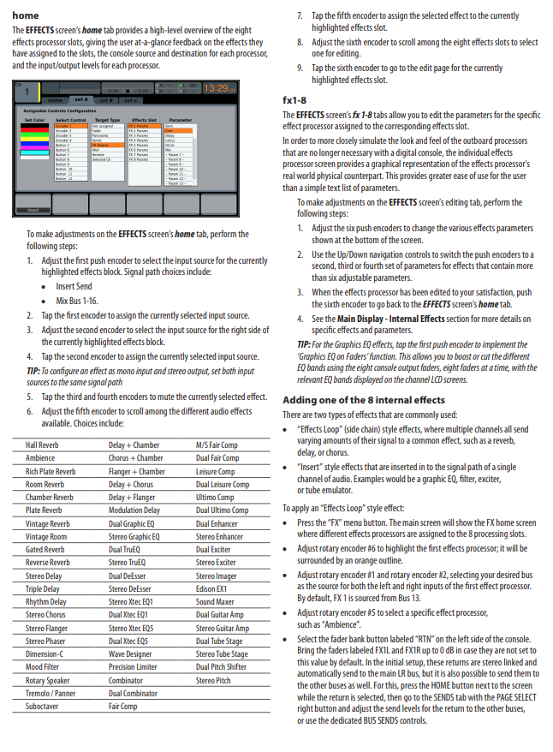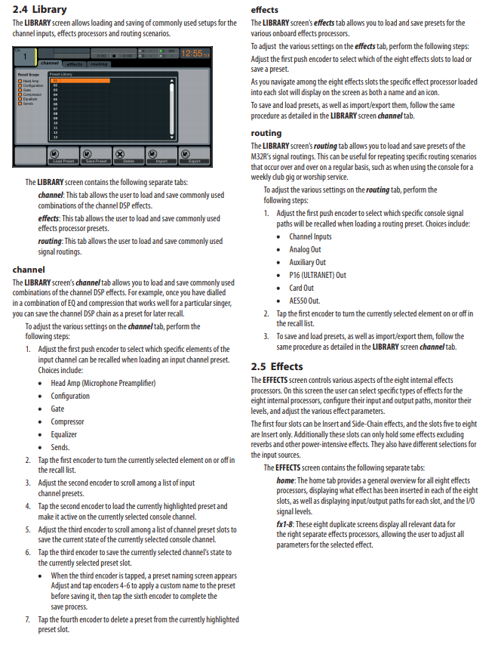

These pages tells me about the library of the audio mixer and the effect. I chose this because on one page it tells me what about the library and what I can I do. The other page talks about how the different effects that the audio mixer has so if I need to add any effects I would now how to do it.

In this screenshot I read about the home. It tells me about the cues, the scenes and more. This will help me cue up the music so that I can just press play for the next track. This also show the utility where I can adjust the cue to how it needs to be.

This page tells me when there is utility and where there are no utilities. This tells me about the mute group and how I can use it. This will help me know where they are

This page tells me about the different speakers. It tells me what they do and how to use them. This will help me know more about the use of the audio mixer

This page tells me about the different these different equipment and what they do and how I can use them. This will help me when we are rehearsing and during the live Tv.

This tells me the about the different EQ’s and how to us it and what they do. The dual and stero deEsser will help me to know what they do how it works.

This page is continuing from the page before it tells me how to do it and what it does so that I know how to use the equipment properly. This will help me to know how to use the equipment and knows how to use the equipment.