Graphic Planning

 | Opening Segment | Round: which round will you be responsible for?  Guess the movie  Pictionary | Other graphics i.e. contestant names, countdown times, questions, answers etc.
Describe the visuals: what will the graphic include visually and why?  You should consider image, colour, font choice/style, positioning etc. | The name of the show will have a letter missing. The word will fade in where the letter bounces into the screen. The colour of the words would be purple and the back ground would be blue. The font would be similar to bubble writing. The position will be in the centre. | This will have the name of the round like guess the movie. This will be different and reflect the round. The name will be the same font and colour. It will be positioned in the centre. Some of the letters could use different fonts like the E could be the E from Disney. For the Pictionary round the colour will be purple and blue but then the font will make it seem like it was written in pencil because we want it to seem like it was drawn. | The questions, contestant and the answers. Will be in purple and blue. The font will be bold but different fonts for the questions, the contestants and the answers. They will either fade in or something different each time. The clock timer will have how much time left. The font is bold like a stopwatch font.
Animation: what will be animated and why? | The I in the name of the show will be missing it will bounce in but the word will fade in this is because I want to create something comedic but different. | The animation will be that it will have like clapper boards moving. This is to reflect movies. The animation for Pictionary is the pencils and paper drawing or moving. | The animation will be different but the clock will be having different clocks around the one clock. This is because it will bring more suspense.
Music/SFX requirements: will there be any music or SFX playing during the graphic screen? If so, what will play and why?  You should locate sources for music and SFX requirements and paste them here. | There will be music and SFX playing during the graphic. The music will be something upbeat. The SFX will be something like a bouncing noise for when the letters bounces in. This is because this will engage the audience more.  https://www.youtube.com/watch?v=5sZZh9d7d68  https://www.youtube.com/watch?v=ze_MZCDyIZ8 | There will be music and SFX.. I want the music to still be upbeat. The SFX will be the clapperboards. The Paper and pencil drawing.  https://www.youtube.com/watch?v=5AnkytyIdMw  https://www.youtube.com/watch?v=1lPdBVmtyBU  https://www.youtube.com/watch?v=t_-PmySa76I  https://www.youtube.com/watch?v=mnd7Ja0KmUg | There will be no music but there will be SFX. The SFX I will use is the clock ticking, the right and wrong noises.  https://www.youtube.com/watch?v=worclOeTALw  https://www.youtube.com/watch?v=AHLCE7iH9qI  https://www.youtube.com/watch?v=uo9dAIQR3g8
Duration: how long does the graphic screen need to play for and why? | I think that the graphic should play on the screen for about 1 minute or less. | I think that the graphic should last for about 1 minute or less. | This could last for about a minute or less.
Mood board: provide visuals of images, text, colour palettes you will use in your graphic screen? | 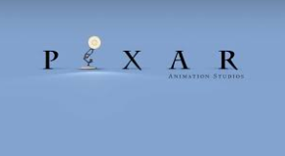   |     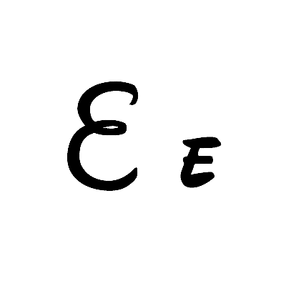 | 