Design Brief

Magazine Title (Masthead): | Style is life
Splash title/topic:  Secondary lead title/topic:  Cover lines title/topic: | Splash title: Trends of 2020  Secondary lead title: Fashion is here  Cover lines title: 2020 trends.
Double page spread title:  Double page spread subheading: | Double page spread title: Trends in 2020 and Make up trends  Double page spread subheading: 2020 is the year for fashion  : New year new look
What are you providing in the final design (front cover):  - Image (original V sourced)  - Pugs  - Buzz words  - Negative space: empty space on the page  - Aligned left/right/middle: how text is positioned and lined up  - Issue number  - Date line  - Typography: text choice and size (provide the size and name of choices)  - Colours  - Design/layout  - Language | For my front cover the images I want to include an image of the latest fashion trend. The main image will be a finished make up look placed on the left side of the page. I want to include an image of makeup looks like eye shadow, lipstick and finished looks that will be placed on the right hand side along with images of a fashion collaborations and trends. I want to Include a pug that catches the audience’s attentions like 50% off. It will be in the bottom left corner. I want to use Buzz words that will catch their attention with words like new trends and 2020. I will align the text on the right hand side of the page. The master head will be at the top of the page but overlaying the image. The strapline, date and issue number will be at underneath the masterhead.  Master head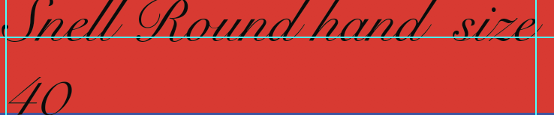  Text  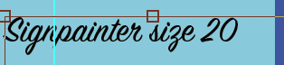  The colors that I am thinking of using is bright colors that go together so it can attract the audience’s attention. The layout will be different. The lay out will have the main image placed to the left side of the page where as the text and the other images will be placed to the right side of the page. The language for the magazine will be informal so the audience can relate to the magazine.
What are you providing in the final design (double page spread):  - Image (original V sourced)  - Buzz words  - Typography: text choice and size (provide the size and name of choices)  - Colours  - Design/layout  - Language  - Ratio of image to text | The images I will use in my double page spread is the different fashion trends and make up trends. The buzz words that I will use tips, 2020, fashion, make up and celebrities. I will place the pictures at the top of left hand side of the page and some other images at the bottom of right page. I will put the text in columns in the bottom left corner and the top right corner. I will place the QR code in the right bottom corner closer to the middle. I will put the words make up tutorial and hyper link it.  Title: 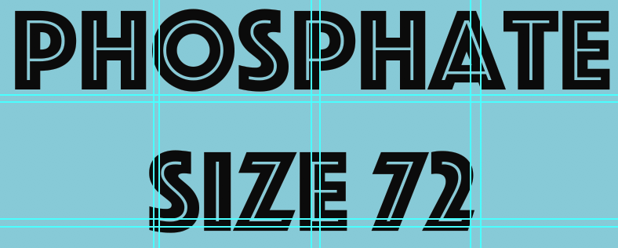  I changed the size of the text to 40  Sub heading  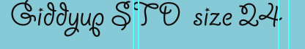  Text:  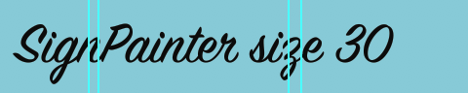  Changed the size to 20  The colors of the double page spread will be bright. The design layout will be on both pages and will have images and articles. On the left page in the top left corner will be some images and in the bottom left will be text in columns . So on the right page will be text in the upper right corner that are in columns and in the bottom corner will be the QR code, the video and images. The language for the magazine will be informal. There will be more images than text so that they can have visuals.
Subject (What are you providing in the written content for the double page spread?)  - Topic  - Interviews  - Facts  - Opinions | The content I am using for my double page spread is fashion trends for 2020 and how to wear them. I will also do tips for make-up. I will look at celebrities that are doing collaborations with brand. I will have different opinions on the trends, the make up and fashion celebrity brands. I will also include facts on the topics so that the reader knows some facts about the topic.
Voice (formal/informal and why?): | The voice I will use is informal. The reason why I am using informal language in the magazine because it helps my target audience to relate to the magazine. Informal language will be used throughout the magazine .
Target audience:  - Primary, secondary and tertiary  - Demographics  - Socio-economic scale  - Psychographics | Primary: 16-18  I want to aim at females that are single. They can be in the demographic of C1, C2, D and E. The Psychographics of the explorer because they like to try new brands. Also, Aspirers because they seek status.  Secondary: 13-15  I want to aim at females that are single. They can be in the demographic of E. The Psychographics of the explorer because they like to try new brands. Also, Aspirers because they seek status.  Tertiary: 19-25  I want to aim at females that are married or single. They can be in the demographics of C1, C2, D and E. For the Psychographics, I chose Aspirers because they care about their appearance, fashion and materialistic things.
Interactive element 1: what will you include and why? How will you go about producing this content? | For my first interactive elements, I will do a hyperlink to Pinterest that has a board of fashion trends they can use to help and guide them of how to wear a certain trend and give them ideas because it is a good idea as they can go back to it and . I will create a board on Pinterest on a different account and look at what they have on it.
Interactive element 2: what will you include and why? How will you go about producing this content? | For this interactive element I decided to do a video about make up. For this I will do a makeover to my friend because I think this a fun way to engage the audience. I also thought this was a creative and different. I will produce this by videoing it like a vlog.
Inspirations: | What inspired me was looking at different magazines and what they do for example vogue had a QR code that lead to a page about the content. Also I watched a video on YouTube that gave me the idea to do a make over as a vlog style video.
Potential problems and contingency plan: | The potential problems that I can have is that I don't know how to do something so I will YouTube what I need to do and learn how to do it. Another problem is that while filming is that the battery could die so I would need to carry extra batteries.
Overall goal: | The overall goal I have is to make my magazine to the best of my abilities and to make it look professional. Another overall goal is to make sure I know where every thing goes.

