
Location Sheet (TV STUDIO)

Production Name: | Hostile
Group Members: | Chloe, Kayley, Callum, Esther and Kacper
Date of Recce: | 14/10/20 + 15/09/20
Date of Production: | 14/10/20 + 15/09/20

Location Name: | College TV studio | Name of Contact: | Kacper Zuber
Location Address: | New Bedford Road, Luton LU2 7BF
 |  | Contact Telephone: | 07512329453
 |  | Contact Email: | ZUB19006010@barnfield.ac.uk

Areas Required: |  | Scenes/Shots being captured at this location:
Stage area (TV studio) |  | Scene 1 Scene 3 Scene 4
Nearest Medical Support: |  | Medical room on campus or L&D hospital.
Safety Concerns: |  | Location is next to a main road and there will be a lot of people throughout as it is in college hour make sure to get permission.  Lights in the TV studio, don’t use really tall objects as it could hit a light
Police Requirement: |  | No police requirements are needed
Security Issues: |  | Swipe badge to get onto the campus to then go into the TV studio
Private/Public Use: |  | Private location
Staging Area: |  | In the TV studio we will be able to place the bags and tripods in and around the area we are using to film. Everything will be able to be placed within this room.
Power Supply: |  | We could use plug sockets and batteries in case we cannot reach the main power supplies
Parking Access: |  | Free parking or a bus stop right outside  Will have to use a badge to get in but only a certain amount of people because of corona
Noise Concerns: |  | We might be able to hear people walking past the TV studio as it is next to the main corridor. We might also hear things being moved around from the department upstairs.
Location Notes:
We are recording on the days that we are in college but we need to wait to see if one of our actors will be allowed inside of the building because of covid-19.

There are plenty of fire exists near the room we are using and loads of ways to access the different rooms and things we need.
Please attach a picture of the location:

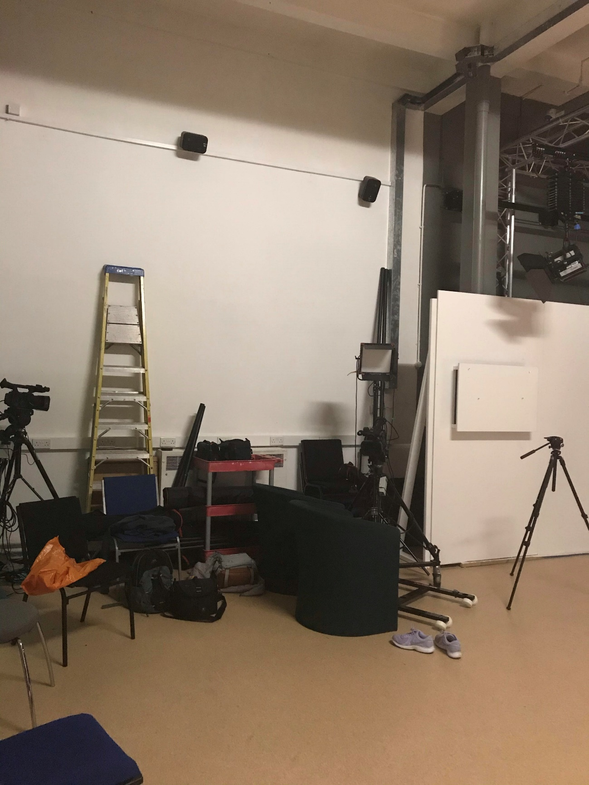

Please attach directions to get to your location:

